| **NAME** | **Mr. Adwait Purao** |
| --- | --- |
| **UID** | **2021300101** |
| **DIV** | **TE CE : BATCH B** |
| **Assignment 2 : List a Indian Startup Company bringing Sustainable Innovation : ZunRoof** | |

**A Case Study of ZunRoof**

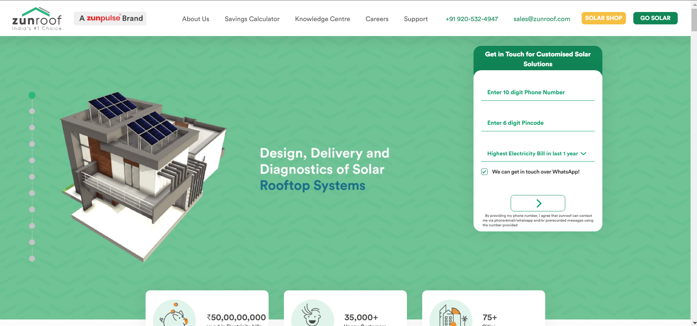

**1) Overview**

ZunRoof, a startup founded by Pranesh Chaudhary and Sushant Sachan, emerged from a vision to harness solar energy for a sustainable future in India. The founders were driven by the pressing need to address energy poverty and climate change in the country. Their journey began with a realization of the vast untapped potential of solar energy, coupled with the challenges faced by homeowners in adopting solar technology due to high upfront costs and lack of information.

**Mission and Values:**

ZunRoof's mission revolves around democratizing solar energy access, empowering homeowners, and combating climate change. The company is dedicated to providing affordable, reliable, and sustainable solar solutions to residential customers across India. Moreover, ZunRoof is committed to environmental sustainability and aims to contribute significantly to reducing the nation's carbon footprint.

**Business Model:**

ZunRoof operates on a disruptive business model that integrates technology, finance, and renewable energy expertise. The company offers end-to-end solar solutions, including rooftop solar installation, financing options, maintenance services, and monitoring systems. By leveraging data analytics and artificial intelligence, ZunRoof optimizes solar system design and energy efficiency, ensuring maximum savings for its customers.

**Product and Services:**

ZunRoof specializes in rooftop solar PV systems tailored to the specific needs and preferences of individual households. Additionally, the company provides innovative solar-powered appliances and energy-efficient solutions to further enhance energy independence and sustainability for its customers. ZunRoof's comprehensive services encompass consultation, installation, maintenance, and ongoing support.

**Marketing Strategy:**

ZunRoof employs a multi-faceted marketing strategy to reach and engage its target audience effectively. The company leverages digital platforms, such as its website, social media channels, and online advertising, to educate consumers about the benefits of solar energy and showcase its products and services. Moreover, ZunRoof utilizes traditional marketing channels, strategic partnerships, and community outreach initiatives to build brand awareness and trust.

**Unique Selling Proposition (USP):**

ZunRoof's unique selling proposition lies in its ability to offer customized solar solutions that cater to the diverse needs of homeowners while ensuring affordability and quality. The company's emphasis on technological innovation, financial flexibility, and customer-centric approach sets it apart in the competitive solar energy market. Additionally, ZunRoof's commitment to transparency, integrity, and customer satisfaction reinforces its reputation as a trusted solar partner.

**Impact and Future Outlook:**

ZunRoof has made significant strides in advancing solar adoption in India, empowering thousands of households to transition to clean energy and reduce their carbon footprint. Looking ahead, the company aims to scale its operations, expand its product portfolio, and reach new markets to accelerate the transition towards a sustainable energy future. ZunRoof remains steadfast in its mission to drive positive environmental and social impact through accessible and affordable solar solutions.

**2) The Sustainable Innovative Model :**

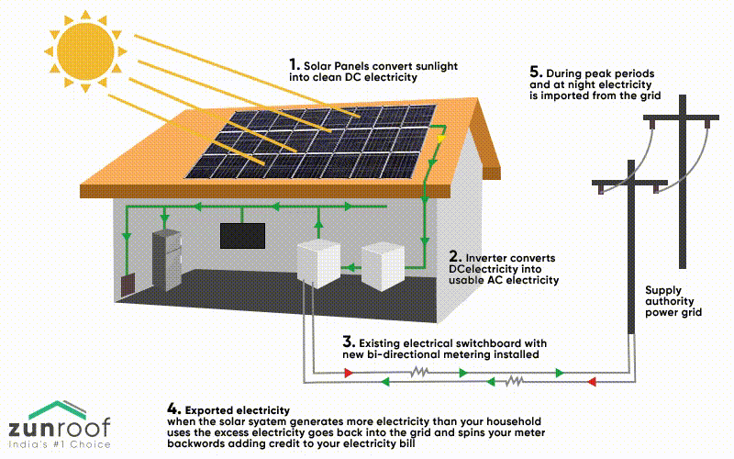

ZunRoof operates on a sustainable and innovative business model aimed at advancing environmental conservation, promoting sustainability, and uplifting marginalized communities. The company embraces a circular economy approach, focusing on harnessing solar energy to mitigate climate change and empower underserved populations.

**Circular Economy Focus:**

ZunRoof's operations revolve around a circular economy model, wherein it leverages solar energy technology to create a sustainable energy ecosystem. By installing rooftop solar panels and other solar-powered solutions, ZunRoof enables homeowners to generate clean and renewable energy, reducing reliance on fossil fuels and minimizing carbon emissions.

**Empowerment of Marginalized Communities:**

ZunRoof is committed to social empowerment and economic inclusion, particularly for marginalized sections of society. The company actively engages with local communities, including women from disadvantaged backgrounds, such as the Dalit community, providing them with employment opportunities and dignified livelihoods. These women play a crucial role in ZunRoof's operations, contributing to the handcrafting of solar products and participating in various aspects of the solar value chain.

**Natural and Eco-Friendly Products:**

ZunRoof emphasizes the production of natural and eco-friendly solar solutions that align with its commitment to environmental sustainability. The company's solar panels and associated products are designed to be charcoal-free and environmentally conscious, minimizing environmental impact throughout their lifecycle. By offering environmentally friendly alternatives to traditional energy sources, ZunRoof promotes sustainable living and reduces ecological footprint.

**Consumer Benefits:**

Customers of ZunRoof benefit from access to high-quality, natural solar solutions that contribute to a cleaner and greener environment. The company's emphasis on innovation and sustainability ensures that consumers receive reliable and efficient solar products tailored to their specific needs. Moreover, by supporting ZunRoof, consumers actively participate in the transition towards renewable energy adoption and contribute to positive social impact initiatives.

**Environmental Impact:**

ZunRoof's sustainable business model has a significant positive environmental impact, contributing to the reduction of greenhouse gas emissions and environmental degradation. By promoting the widespread adoption of solar energy, ZunRoof plays a vital role in combating climate change and fostering a more sustainable future for generations to come. The company's efforts align with global sustainability goals and demonstrate the transformative potential of renewable energy technologies.

**Future Outlook:**

As ZunRoof continues to expand its operations and reach, the company remains committed to its core principles of environmental stewardship, social responsibility, and technological innovation. With a focus on scaling renewable energy adoption and empowering marginalized communities, ZunRoof seeks to make a lasting and meaningful impact on both the environment and society. Through ongoing research, development, and collaboration, ZunRoof aims to drive positive change and pave the way for a more sustainable and inclusive world.

**3) Getting the Finances Sorted : Receiving Funding :**

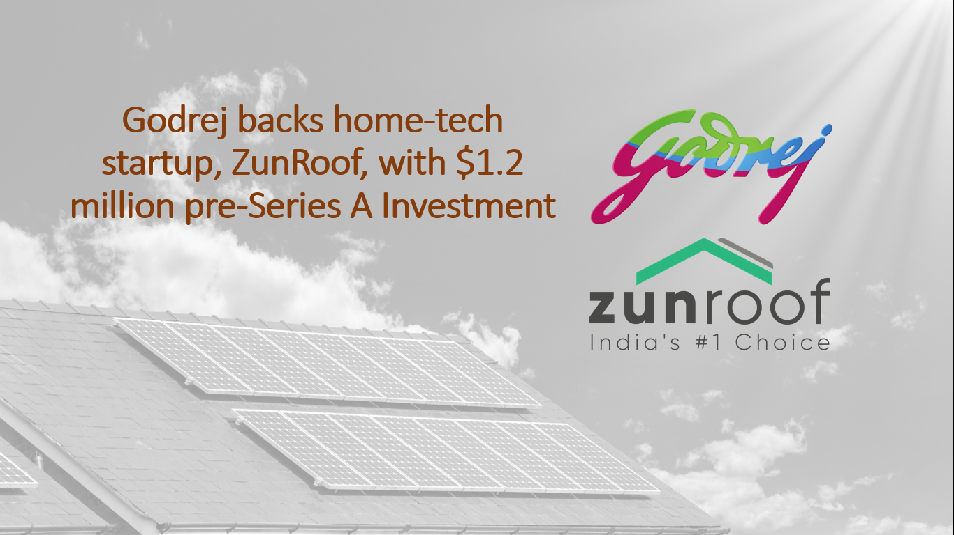

In 2016, ZunRoof was founded and soon caught the attention of investors due to its innovative approach to harnessing solar energy. The company gained significant visibility when it secured funding from the family office of the business conglomerate, the Godrej Group. This investment not only provided financial support but also added credibility to the company.

ZunRoof has successfully raised capital through multiple funding rounds. The company has raised a total of $6.05M over 7 rounds from 35 investors. Notable investors include Groundupp Ventures and Godrej.

In its Series A round on March 16, 2020, ZunRoof raised $3M from the Godrej family office. Prior to this, in April 2019, the company had raised $1.2M in a pre-Series A round, also from the Godrej family office.

The funding has enabled ZunRoof to expand its operations, strengthen its product portfolio, and continue its mission to solve electricity issues in India through rooftop solar and monitoring electrical appliances in homes.

**A Detailed Funding Details of ZunRoof**

| **Capital Investment Phase** | **Source of Funding** | **Amount Raised** |
| --- | --- | --- |
| **Pre Seed Round (2016)** | **Own Funds** | **$70K** |
| **Angel Round I (2018)** | **Intellecap Impact Investment Network, Arun Diaz, Ramakant Sharma, and others** | **₹16.6M** |
| **Angel Round II (2018)** | **Arun Diaz, Ramakant Sharma, and others** | **₹11.4M** |
| **Series A Round I (2019)** | **Godrej family office** | **$1.2M** |
| **Series A Round II (2020)** | **Godrej family office** | **$3M** |
| **Unknown Round (2021)** | **Groundupp Ventures, Godrej and others** | **$1.36M** |

**4) The Sustainable Technology :**

Kartik Marwah, Pranesh Chaudhary, and Sushant Sachan, the founders of ZunRoof, met with various industry experts and technologists who were impressed by their idea. They were introduced to the world of solar energy and IoT-based smart energy solutions. This marked the beginning of ZunRoof's journey.

The incubation of ZunRoof started in their own homes, where they began to develop their unique solar rooftop systems. They received support from various investors and industry experts, which helped them recruit top-quality talents and build a dedicated infrastructure for the company.

The R&D department of ZunRoof is one of their greatest assets. The founders, being technical entrepreneurs, find fulfillment in developing new products and finding solutions to electricity issues in India. They are engrossed in creating a product and not just the commercialization of the products. Therefore, they have struck a balance between green innovations and their marketability for successful ventures. They have developed an app to manage the end-to-end experience of going solar with three modules: design, delivery, and diagnostics. Their Remote Monitoring System provides real-time updates to smartly monitor solar energy generation.

**5) Result of Sustainability and Social Initiatives :**

The products at ZunRoof are designed and installed by a team of dedicated professionals who are passionate about harnessing solar energy. This not only provides them with a respectable source of livelihood but also contributes to the larger goal of sustainability. ZunRoof has employed individuals from various backgrounds, providing them with opportunities to contribute to the green energy sector.

Before joining ZunRoof, many of these individuals may not have had the opportunity to work in the renewable energy sector. Today, they are proud to be a part of ZunRoof, where they are helping to make clean power accessible and affordable to individuals and businesses. By reducing reliance on fossil fuels, they contribute to mitigating climate change and reducing carbon emissions.

Moreover, ZunRoof's solar solutions are making Indian homes green and future-ready. The company's IoT-powered diagnostics provide real-time updates to smartly monitor solar energy generation. This not only helps homeowners save on electricity bills but also promotes the use of renewable energy. In this way, ZunRoof is not only contributing to environmental sustainability but also promoting social initiatives by creating employment opportunities in the green energy sector.

**6) The UN Sustainable Devlopement Goals Covered by ZunRoof:**

1. **SDG 7** - Affordable and Clean Energy: ZunRoof directly contributes to this goal by providing affordable and clean energy solutions. They install solar panels on rooftops to harness solar energy, thereby promoting the use of renewable energy.
2. **SDG 9** - Industry, Innovation, and Infrastructure: ZunRoof innovates in the renewable energy sector with their IoT-powered diagnostics, providing real-time updates to smartly monitor solar energy generation.
3. **SDG 11** - Sustainable Cities and Communities: By making homes green and future-ready, ZunRoof contributes to the creation of sustainable cities and communities.
4. **SDG 13** - Climate Action: ZunRoof reduces reliance on fossil fuels and promotes the use of renewable energy, helping to mitigate climate change and reduce carbon emissions.

**7) The Website Interface :**

**1) Home and About Us:**

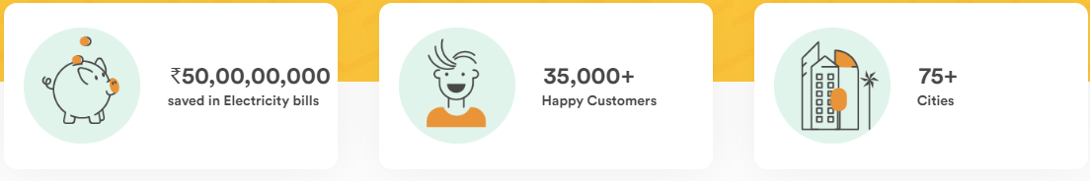

**Why ZunRoof:**

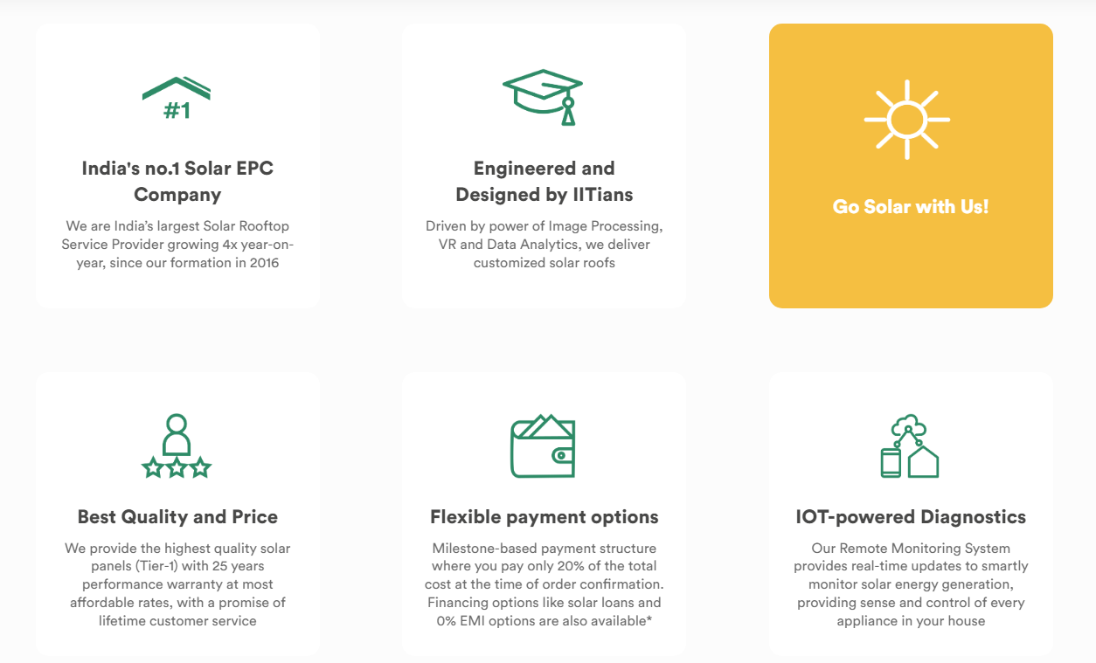

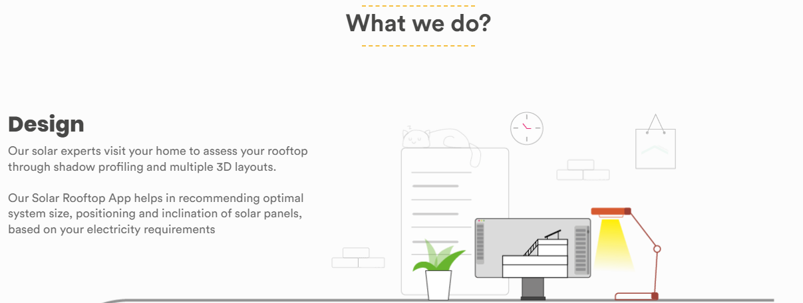

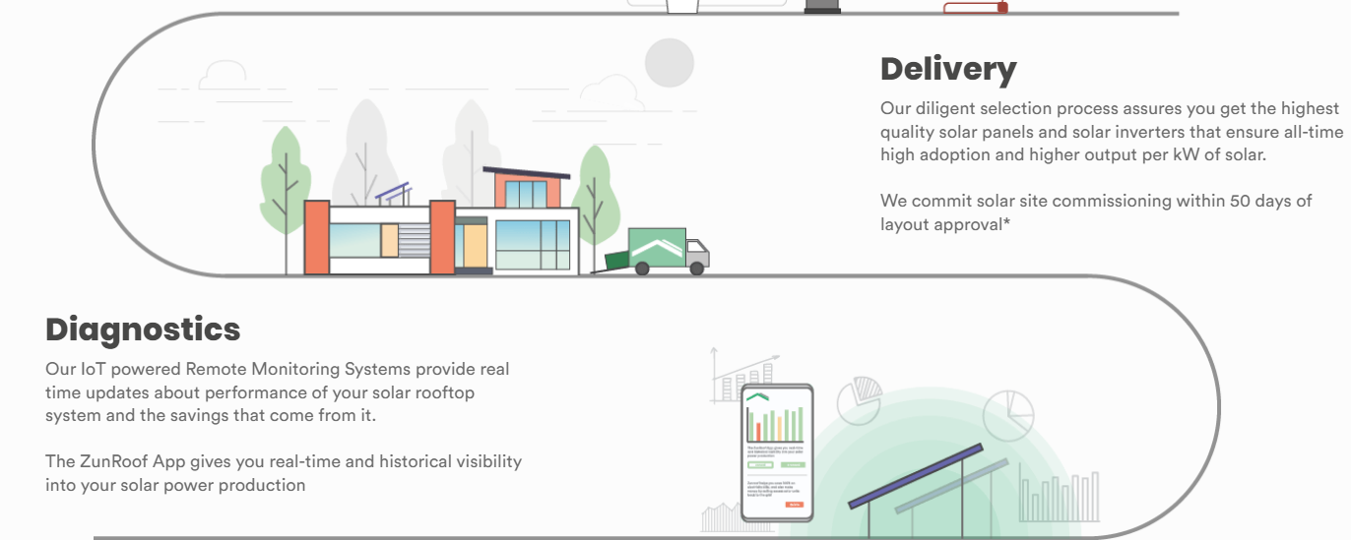

**2) Their Products :**

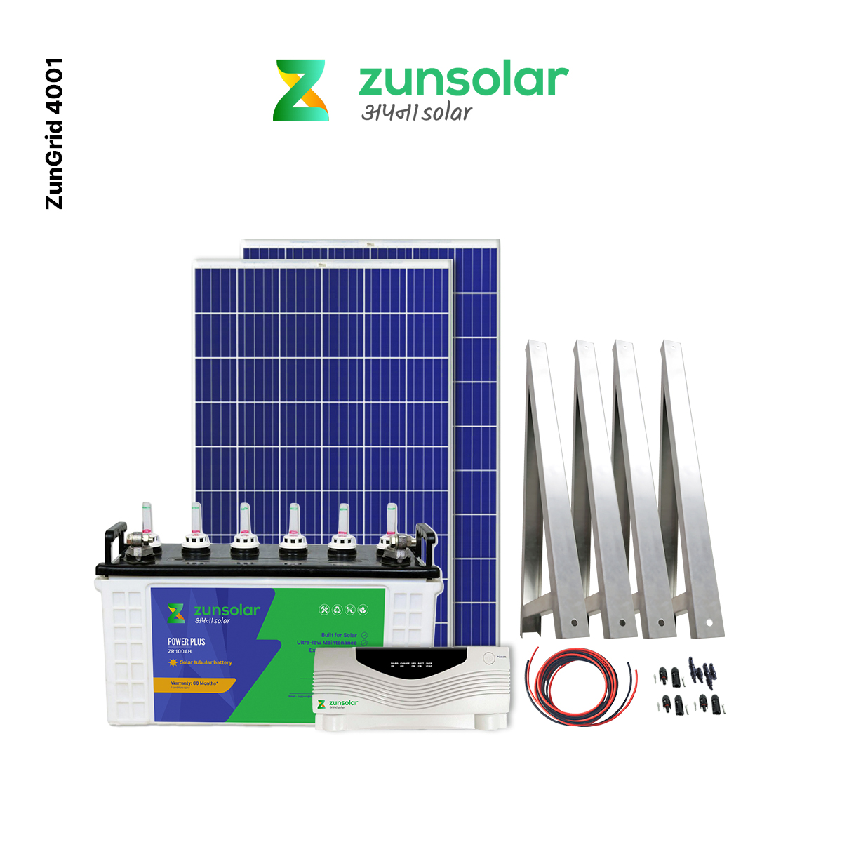



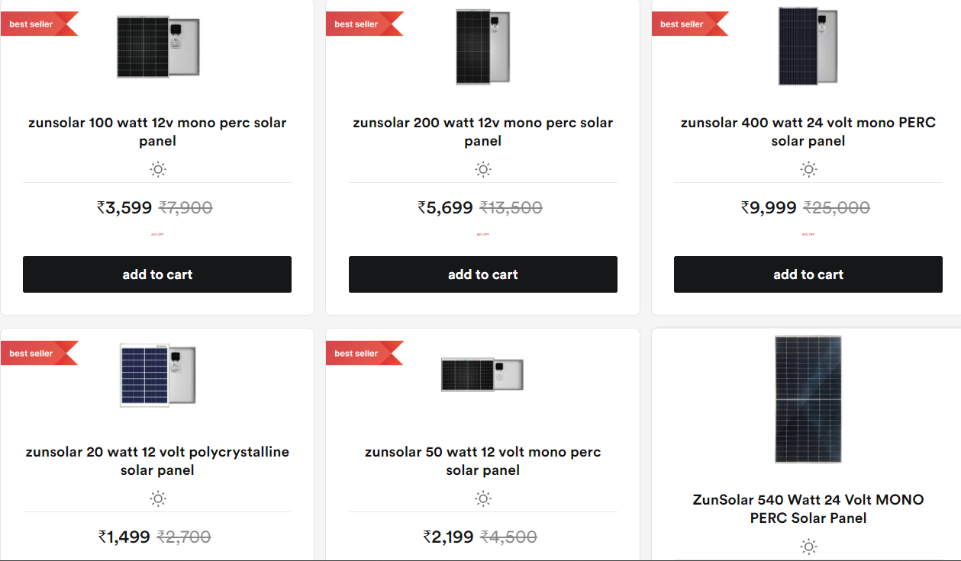

Youtube : <https://youtu.be/6h7GT0KGqAU>

**8) Reference :**

1. Crunchbase. (n.d.). [ZunRoof - Crunchbase Company Profile & Funding1](https://www.crunchbase.com/organization/zunroof).
2. YourStory. (2020, July 25). [[The Turning Point] Why these friends launched solar energy solutions startup ZunRoof](https://www.crunchbase.com/organization/zunroof)[2](https://yourstory.com/2020/07/turning-point-zunroof-solar-energy-solutions-startup-pranesh-chaudhary).
3. EverybodyWiki Bios & Wiki. (n.d.). [ZunRoof](https://www.crunchbase.com/organization/zunroof)[3](https://en.everybodywiki.com/ZunRoof).
4. YourStory. (n.d.). [ZunRoof Tech Company Profile, information, investors](https://www.crunchbase.com/organization/zunroof)[4](https://yourstory.com/companies/zunroof-tech).
5. YourStory. (n.d.). [ZunRoof - EverybodyWiki Bios & Wiki3](https://en.everybodywiki.com/ZunRoof).